Assignment on University DataBase Management System

Task 1:
- Create University Database give any University name you want
Ans: CREATE DATABASE PUNEUNIVERSITY;

USE PUNEUNIVERSITY;

- Under this University Create four tables and each table should have following three Column named as –
Ans: CREATE TABLE COLLEGE_TABLE (
COLLEGE_ID INT PRIMARY KEY,
COLLEGE_NAME VARCHAR(100),
COLLEGE_AREA VARCHAR(100));

SELECT * FROM COLLEGE_TABLE;
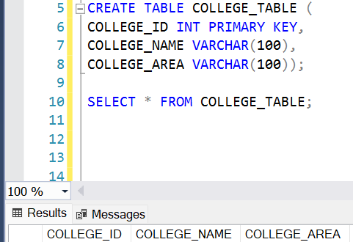
CREATE TABLE DEPARTMENT_TABLE (
DEPT_ID INT PRIMARY KEY,
DEPT_NAME VARCHAR(100),
DEPT_FACILITY VARCHAR(100));

SELECT * FROM DEPARTMENT_TABLE;
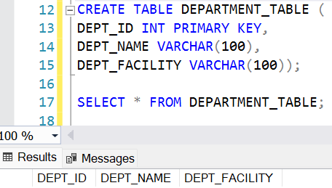
CREATE TABLE PROFESSOR_TABLE (
PROFESSOR_ID INT PRIMARY KEY,
PROFESSOR_NAME VARCHAR(100),
PROFESSOR_SUBJECT VARCHAR(100));

SELECT * FROM PROFESSOR_TABLE;
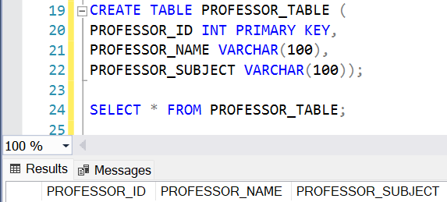
CREATE TABLE STUDENT_TABLE (
STUDENT_ID INT PRIMARY KEY,
STUDENT_NAME VARCHAR(100),
STUDENT_STREAM VARCHAR(100));

SELECT * FROM STUDENT_TABLE;
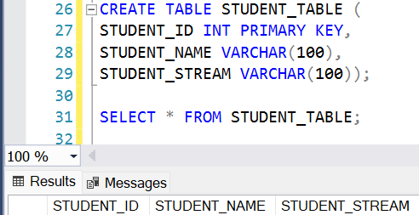

- Apply foreign key on Department key from College_table
Ans: DROP TABLE DEPARTMENT_TABLE;

CREATE TABLE DEPARTMENT_TABLE (
DEPT_ID INT PRIMARY KEY,
DEPT_NAME VARCHAR(100),
DEPT_FACILITY VARCHAR(100),
COLLEGE_ID INT,
FOREIGN KEY (COLLEGE_ID) REFERENCES COLLEGE_TABLE(COLLEGE_ID));
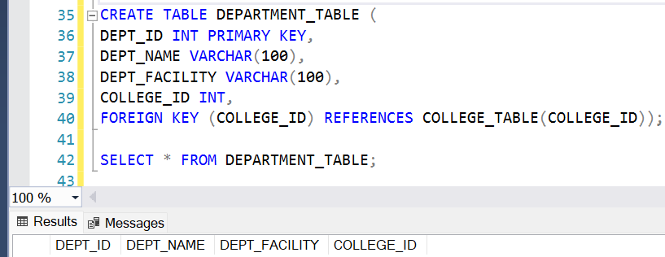

- Apply foreign Key on Student_Table from Professor_Table
Ans: DROP TABLE STUDENT_TABLE;

CREATE TABLE STUDENT_TABLE (
STUDENT_ID INT PRIMARY KEY,
STUDENT_NAME VARCHAR(100),
STUDENT_STREAM VARCHAR(100),
PROFESSOR_ID INT,
FOREIGN KEY (PROFESSOR_ID) REFERENCES PROFESSOR_TABLE(PROFESSOR_ID));
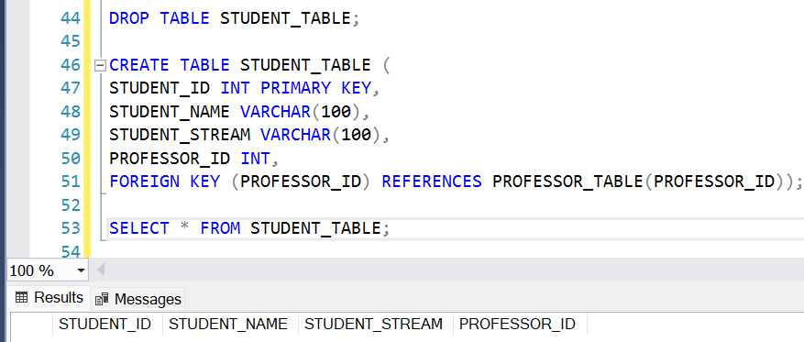

- Insert atleast 10 Records in each table
Ans: INSERT INTO COLLEGE_TABLE VALUES
(1, 'FERGUSSON COLLEGE', 'SHIVAJI NAGAR'),
(2, 'SP COLLEGE', 'TILAK ROAD'),
(3, 'MODERN COLLEGE', 'SHIVAJI NAGAR'),
(4, 'BMCC', 'DECCAN'),
(5, 'WADIA COLLEGE', 'BUND GARDEN'),
(6, 'MIT COLLEGE', 'KOTHRUD'),
(7, 'COEP', 'SHIVAJI NAGAR'),
(8, 'SYMBIOSIS COLLEGE', 'SENAPATI BAPAT ROAD'),
(9, 'GARWARE COLLEGE', 'KARVE ROAD'),
(10, 'SINHGAD COLLEGE', 'VADGAON');
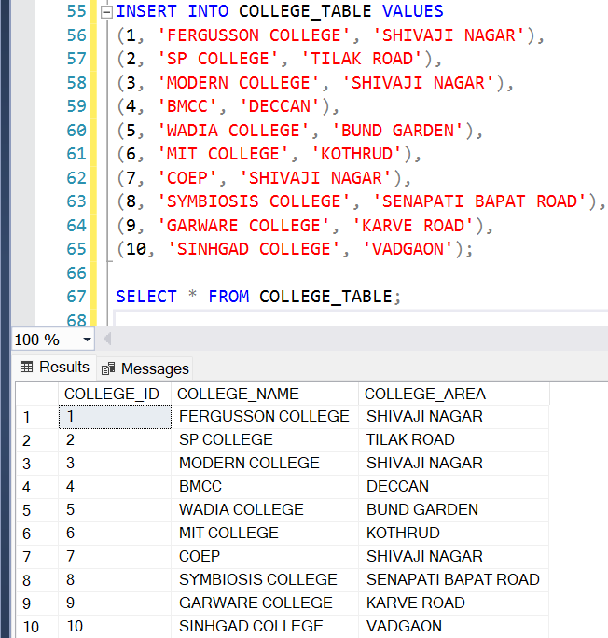
INSERT INTO DEPARTMENT_TABLE VALUES
(1, 'COMPUTER SCIENCE', 'LAB FACILITY', 1),
(2, 'MATHEMATICS', 'LIBRARY ACCESS', 1),
(3, 'PHYSICS', 'RESEARCH LAB', 2),
(4, 'CHEMISTRY', 'CHEMICAL LAB', 3),
(5, 'BIOLOGY', 'BOTANICAL GARDEN', 4),
(6, 'ECONOMICS', 'SEMINAR HALL', 5),
(7, 'HISTORY', 'ARCHIVE FACILITY', 6),
(8, 'ENGLISH', 'LANGUAGE LAB', 7),
(9, 'ELECTRONICS', 'CIRCUIT LAB', 8),
(10, 'MECHANICAL', 'WORKSHOP', 9);
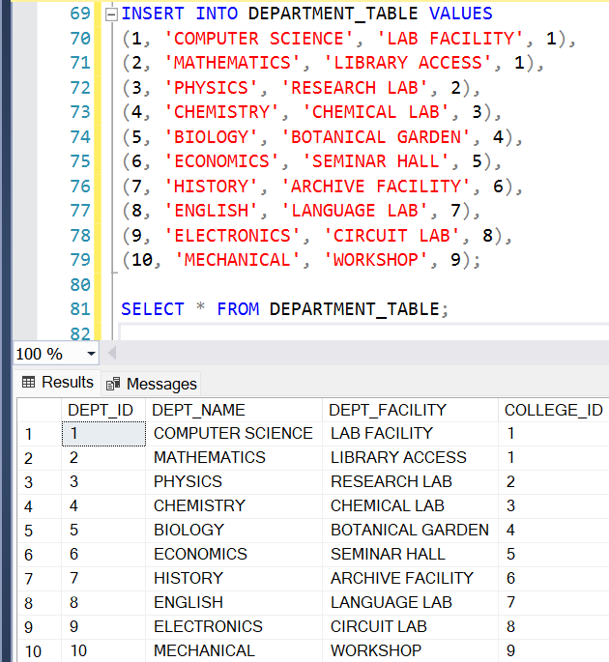

INSERT INTO PROFESSOR_TABLE VALUES
(1, 'DR. PATIL', 'ARTIFICIAL INTELLIGENCE'),
(2, 'DR. KULKARNI', 'ALGEBRA'),
(3, 'DR. DESKMUKH', 'QUANTUM PHYSICS'),
(4, 'DR. JOSHI', 'ORGANIC CHEMISTRY'),
(5, 'DR. NAIR', 'BOTANY'),
(6, 'DR. RAO', 'MICROECONOMICS'),
(7, 'DR. GOKHALE', 'INDIAN HISTORY'),
(8, 'DR. SHARMA', 'ENGLISH LITERATURE'),
(9, 'DR. MORE', 'EMBEDDED SYSTEMS'),
(10, 'DR. SAWANT', 'THERMODYNAMICS');
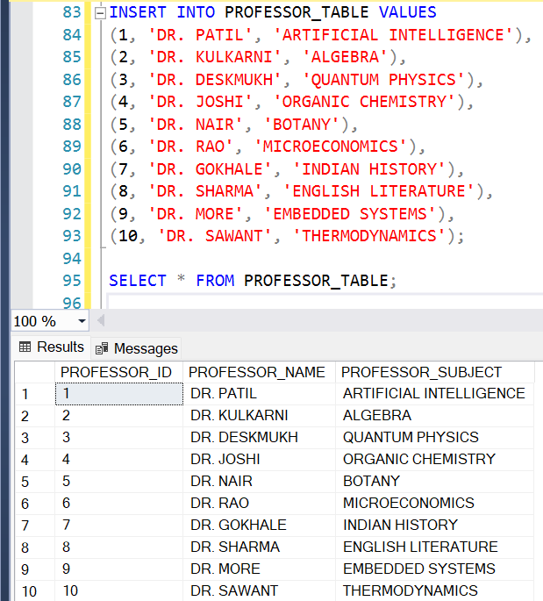

INSERT INTO STUDENT_TABLE VALUES
(1, 'AMIT', 'BSc CS', 1),
(2, 'SNEHA', 'BSc MATH', 2),
(3, 'ROHIT', 'BSc PHYSICS', 3),
(4, 'PRIYA', 'BSc CHEMISTRY', 4),
(5, 'KIRAN', 'BSc BIO', 5),
(6, 'MEENA', 'BA ECO', 6),
(7, 'VIKAS', 'BA HISTORY', 7),
(8, 'KOMAL', 'BA ENGLISH', 8),
(9, 'SAGAR', 'BSc ELECTRONICS', 9),
(10, 'NEHA', 'BE MECHANICAL', 10);
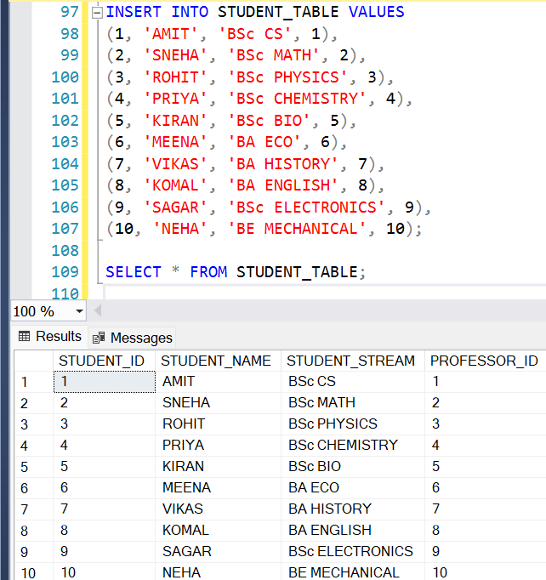

Task 2:
- Give the information of College_ID and College_name from College_Table
Ans: SELECT COLLEGE_ID, COLLEGE_NAME
FROM COLLEGE_TABLE;
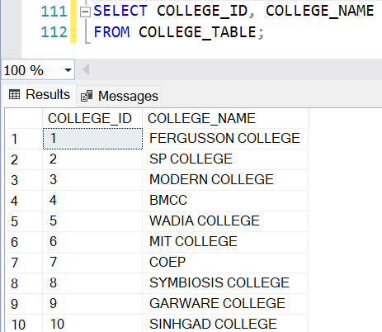

- Show Top 5 rows from Student table.
Ans: SELECT TOP 5 *
FROM STUDENT_TABLE;
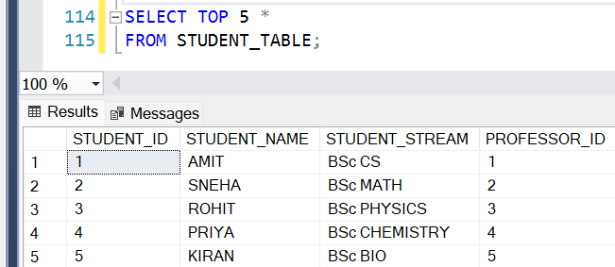

- What is the name of professor whose ID is 5
Ans: SELECT PROFESSOR_NAME
FROM PROFESSOR_TABLE
WHERE PROFESSOR_ID = 5;
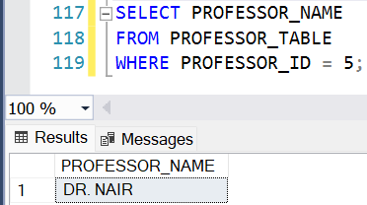
- Convert the name of the Professor into Upper case
Ans: SELECT UPPER(PROFESSOR_NAME) AS PROFESSOR_NAME_UPPER
FROM PROFESSOR_TABLE;
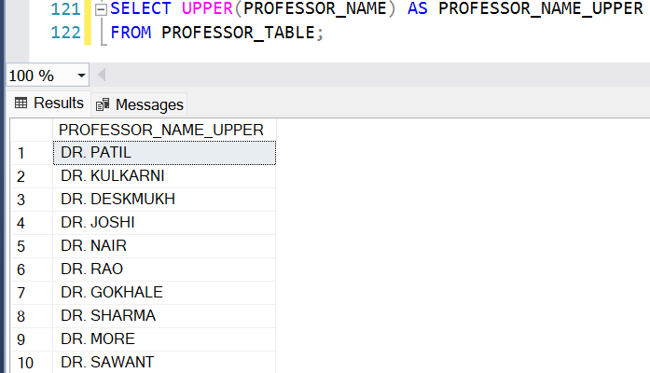

- Show me the names of those students whose name is start with a
Ans: SELECT STUDENT_NAME
FROM STUDENT_TABLE
WHERE STUDENT_NAME LIKE 'A%';
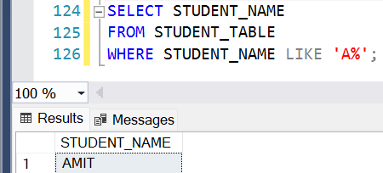

- Give the name of those colleges whose end with a
Ans: SELECT COLLEGE_NAME
FROM COLLEGE_TABLE
WHERE COLLEGE_NAME LIKE '%A %';
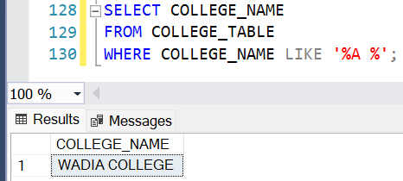

- Add one Salary Column in Professor_Table
Ans: ALTER TABLE PROFESSOR_TABLE
ADD PROFESSOR_SALARY DECIMAL(10,2);
UPDATE Professor_table SET professor_salary = 80000 WHERE professor_id = 1;
UPDATE Professor_table SET professor_salary = 75000 WHERE professor_id = 2;
UPDATE Professor_table SET professor_salary = 70000 WHERE professor_id = 3;
UPDATE Professor_table SET professor_salary = 72000 WHERE professor_id = 4;
UPDATE Professor_table SET professor_salary = 68000 WHERE professor_id = 5;
UPDATE Professor_table SET professor_salary = 65000 WHERE professor_id = 6;
UPDATE Professor_table SET professor_salary = 77000 WHERE professor_id = 7;
UPDATE Professor_table SET professor_salary = 71000 WHERE professor_id = 8;
UPDATE Professor_table SET professor_salary = 73000 WHERE professor_id = 9;
UPDATE Professor_table SET professor_salary = 69000 WHERE professor_id = 10;
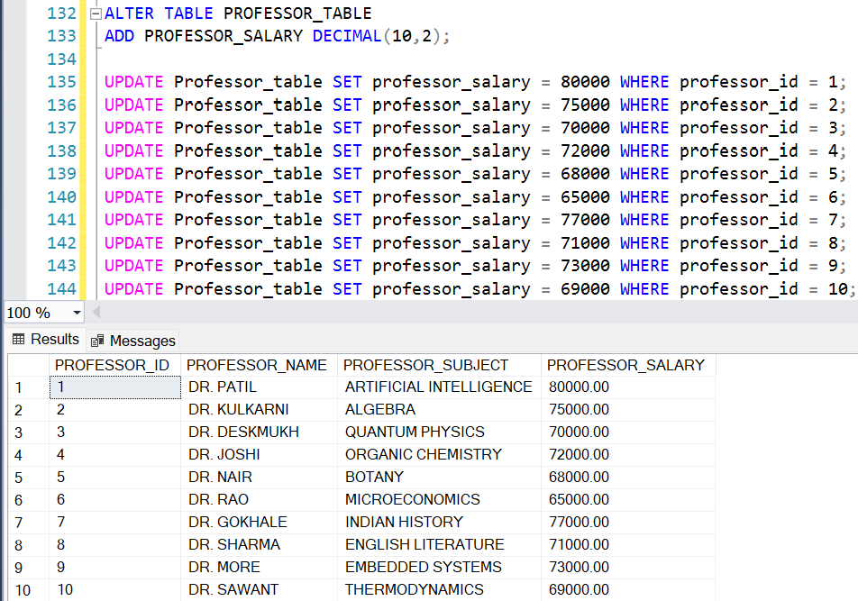

- Add one Contact Column in Student_table
Ans: ALTER TABLE STUDENT_TABLE
ADD STUDENT_CONTACT VARCHAR(15);
UPDATE Student_table SET student_contact = '9876543210' WHERE student_id = 1;
UPDATE Student_table SET student_contact = '9123456780' WHERE student_id = 2;
UPDATE Student_table SET student_contact = '9988776655' WHERE student_id = 3;
UPDATE Student_table SET student_contact = '9090909090' WHERE student_id = 4;
UPDATE Student_table SET student_contact = '9911223344' WHERE student_id = 5;
UPDATE Student_table SET student_contact = '9000011111' WHERE student_id = 6;
UPDATE Student_table SET student_contact = '9555666777' WHERE student_id = 7;
UPDATE Student_table SET student_contact = '9444333222' WHERE student_id = 8;
UPDATE Student_table SET student_contact = '9333444555' WHERE student_id = 9;
UPDATE Student_table SET student_contact = '9222333444' WHERE student_id = 10;
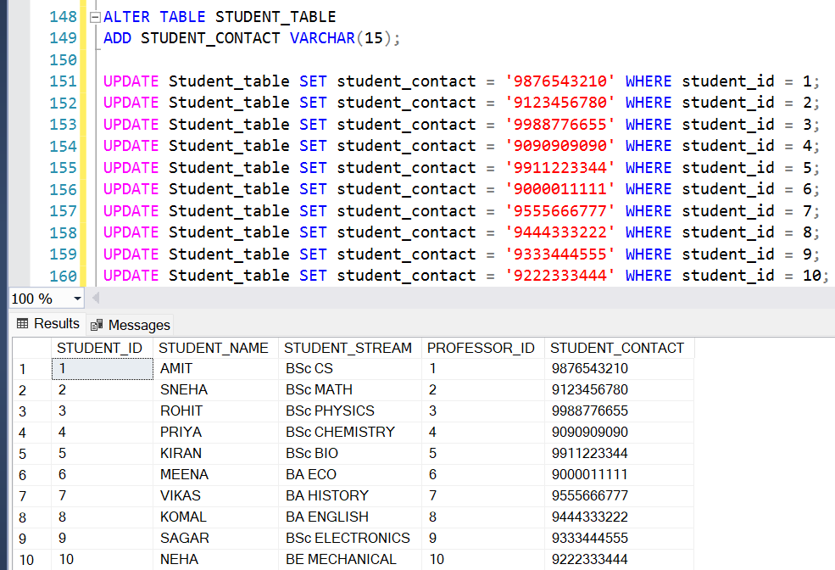

- Find the total Salary of Professor
Ans: SELECT SUM(PROFESSOR_SALARY) AS TOTAL_SALARY
FROM PROFESSOR_TABLE;
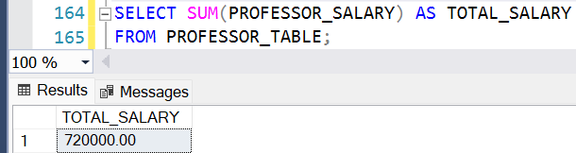

- Change datatype of any one column of any one Table.
Ans: ALTER TABLE STUDENT_TABLE
ALTER COLUMN STUDENT_CONTACT BIGINT;

UPDATE Student_table SET student_contact = 9876543210 WHERE student_id = 1;
UPDATE Student_table SET student_contact = 9123456780 WHERE student_id = 2;
UPDATE Student_table SET student_contact = 9988776655 WHERE student_id = 3;
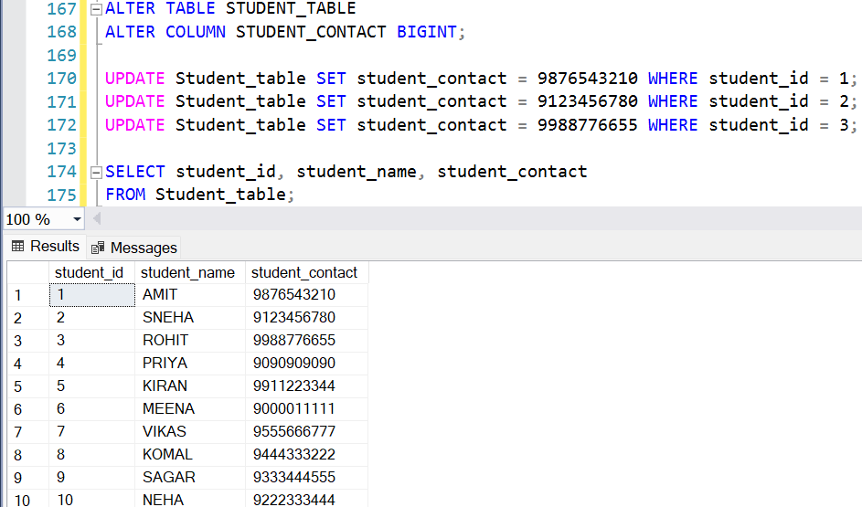

Task 3:
- Show first 5 records from Students table and Professor table Combine.
Ans: WITH FIRSTSTUDENTS AS (
SELECT TOP (5)
STUDENT_ID AS ID, STUDENT_NAME AS NAME,
STUDENT_STREAM AS STREAM
FROM STUDENT_TABLE
ORDER BY STUDENT_ID),
FIRSTPROFESSORS AS (
SELECT TOP (5)
PROFESSOR_ID AS ID,
PROFESSOR_NAME AS NAME,
PROFESSOR_SUBJECT AS SUBJECT
FROM PROFESSOR_TABLE
ORDER BY PROFESSOR_ID)
SELECT * FROM FIRSTSTUDENTS
UNION ALL
SELECT * FROM FIRSTPROFESSORS;
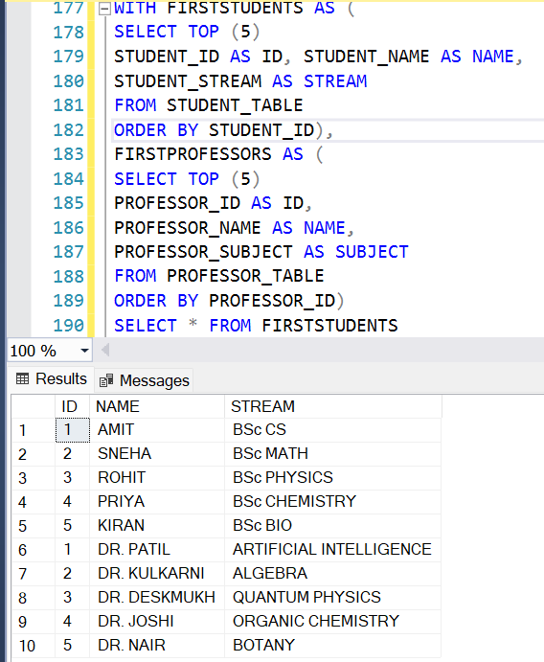

- Apply Inner join on all 4 tables together (Syntax is mandatory)
Ans: UPDATE Department_table SET college_id = 1 WHERE dept_id IN (1,2);
UPDATE Department_table SET college_id = 2 WHERE dept_id IN (3,4);
UPDATE Department_table SET college_id = 3 WHERE dept_id IN (5,6);
UPDATE Department_table SET college_id = 4 WHERE dept_id IN (7,8);
UPDATE Department_table SET college_id = 5 WHERE dept_id IN (9,10);

UPDATE Professor_table SET dept_id = 1 WHERE professor_id IN (1,2);
UPDATE Professor_table SET dept_id = 2 WHERE professor_id IN (3,4);
UPDATE Professor_table SET dept_id = 3 WHERE professor_id IN (5,6);
UPDATE Professor_table SET dept_id = 4 WHERE professor_id IN (7,8);
UPDATE Professor_table SET dept_id = 5 WHERE professor_id IN (9,10);

UPDATE Student_table SET professor_id = 1 WHERE student_id IN (1,2);
UPDATE Student_table SET professor_id = 2 WHERE student_id IN (3,4);
UPDATE Student_table SET professor_id = 3 WHERE student_id IN (5,6);
UPDATE Student_table SET professor_id = 4 WHERE student_id IN (7,8);
UPDATE Student_table SET professor_id = 5 WHERE student_id IN (9,10);

SELECT
C.COLLEGE_ID, C.COLLEGE_NAME, C.COLLEGE_AREA,
D.DEPT_ID AS DEPT_ID_FROM_DEPARTMENT, D.DEPT_NAME, D.DEPT_FACILITY,
P.PROFESSOR_ID, P.PROFESSOR_NAME, P.PROFESSOR_SUBJECT, P.DEPT_ID AS DEPT_ID_FROM_PROFESSOR,
S.STUDENT_ID, S.STUDENT_NAME, S.STUDENT_STREAM, S.PROFESSOR_ID AS PROFESSOR_ID_FROM_STUDENT
FROM COLLEGE_TABLE C
INNER JOIN DEPARTMENT_TABLE D ON C.COLLEGE_ID = D.COLLEGE_ID
INNER JOIN PROFESSOR_TABLE P ON D.DEPT_ID = P.DEPT_ID
INNER JOIN STUDENT_TABLE S ON P.PROFESSOR_ID = S.PROFESSOR_ID;
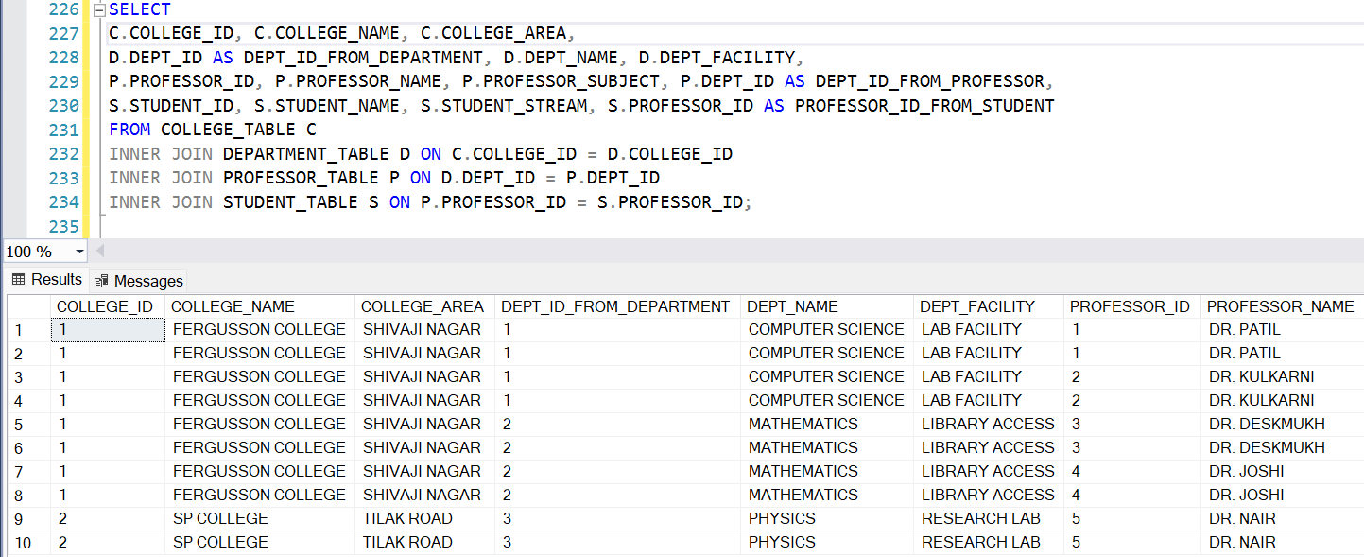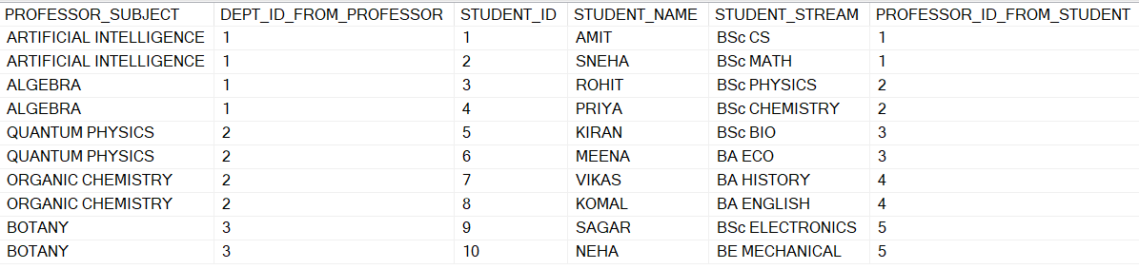

- Show Some null values from Department table and Professor table.
Ans: SELECT D.DEPT_ID, D.DEPT_NAME, D.DEPT_FACILITY,
P.PROFESSOR_ID, P.PROFESSOR_NAME, P.PROFESSOR_SUBJECT
FROM DEPARTMENT_TABLE D
LEFT JOIN PROFESSOR_TABLE P
ON D.DEPT_ID = P.DEPT_ID
WHERE P.PROFESSOR_ID IS NULL;

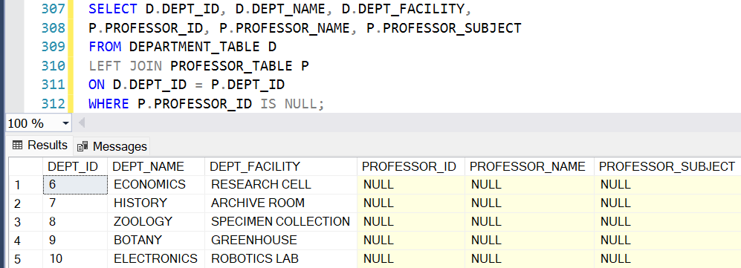

- Create a View from College Table and give those records whose college name starts with C
Ans: CREATE VIEW COLLEGE_C_VIEW AS
SELECT * FROM COLLEGE_TABLE
WHERE COLLEGE_NAME LIKE 'C%';

SELECT * FROM COLLEGE_C_VIEW;
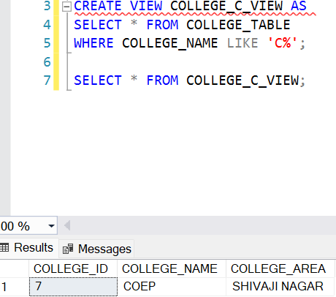

- Create Stored Procedure of Professor table whatever customer ID will be given by user it should show whole records of it.
Ans: CREATE PROCEDURE GETPROFESSORBYID @PROF_ID INT
AS
BEGIN
SELECT * FROM PROFESSOR_TABLE
WHERE PROFESSOR_ID = @PROF_ID;
END;
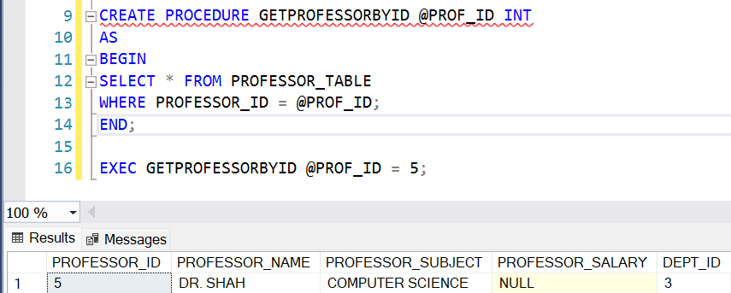

- Rename the College_Table to College_Tables_Data .
Ans: EXEC sp_rename 'COLLEGE_TABLE', 'COLLEGE_TABLES_DATA';

SELECT * FROM COLLEGE_TABLES_DATA;
